Lab assignment 1:
Write a Java programme to swap values of two variables.
i> using a third variable
public class Swap {
public static void main(String[] args) {
int a = 68;
int b = 69;

// Swapping logic using a temporary variable
int c = a;
a = b;
b = c;

System.out.println("a = " + a);
System.out.println("b = " + b);
}
}

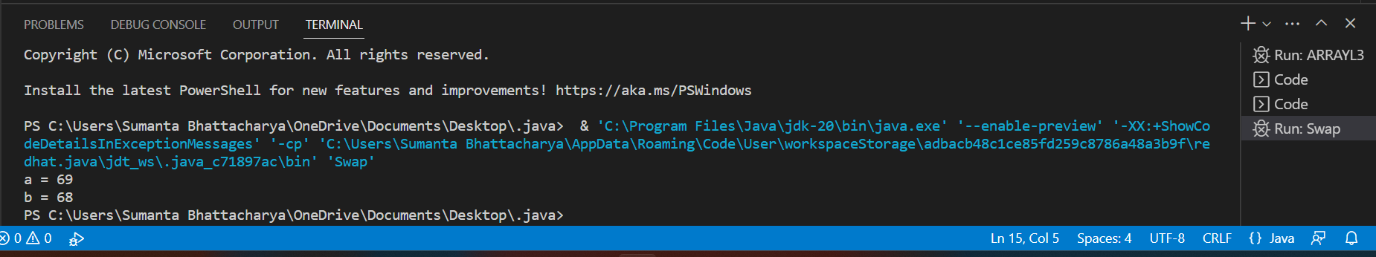

ii> without using third variable
public class SWAP3 {
public static void main(String[] args) {
int a = 2;
int b = 3;
a = a + b;
b = a - b;
a = a - b;
System.out.println("a = " + a);
System.out.println("b = " + b);
}
}

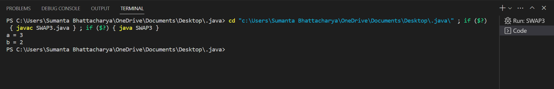

Discuss which approach among the above two, you think is more efficient.

Efficiency Discussion
Between the two approaches, using a third variable is generally considered more readable, maintainable, and less error-prone. It's easier for someone else (or even your future self) to understand the intent of the code when a temporary variable is used.
In terms of performance, the approach using a third variable might have a negligible impact on modern computers, as memory access is generally fast. The arithmetic operations in the second approach could lead to subtle issues like overflow if the variables are large enough.
However, the difference in performance between these two approaches is minimal for most practical cases. In terms of execution time, it's unlikely that you would notice a significant difference.
Therefore, it's recommended to prioritize code readability and maintainability over micro-optimizations in most cases. If performance is a critical concern, you should consider other optimization techniques that are more impactful than the choice between using or not using a third variable for swapping.

Lab Assignment 3:
Design a simple game using Java.
Game title: Illusion of Choice
Objective: Users will be given choices and the impression that they can win, but the system will always win!
Rules: It is a two-player game between a human and a computer program. One player can choose one or two integers starting from 1, and the other must pick up the next one or two integers. There will be a predefined limit (20 for version 1 and user input for version 2); whoever gets to pick that integer wins the game!

import java.util.Scanner;

public class Main_A3 {
public static void main(String[] args) {
Scanner input = new Scanner(System.in);
System.out.print("How many numbers do you want to play? : ");
int x = input.nextInt();
int b;

switch (x % 3) {
case 0:
b = 1;
choice(b, x);
break;
case 1:
b = 1;
System.out.println("Computer choice: " + b);
choice(b + 1, x);
break;
case 2:
b = 2;
System.out.println("Computer choice: " + (b - 1) + " and " + b);
choice(b + 1, x);
break;
}
}

static void choice(int j, int x) {
int b = 0;
while (j <= x) {
int i = 0, k = j;
Scanner input1 = new Scanner(System.in);
System.out.println("User choice:");
System.out.print("How many numbers do you want to put among 1 and 2 numbers: ");
int a = input1.nextInt();

if (a == 1 || a == 2) {
k = j;
while (i < a) {
System.out.print("Enter " + (i + 1) + " no data: ");
b = input1.nextInt();
if (b != k) {
System.out.println("Enter valid input.");
} else {
k++;
i++;
}
}

if (b == x) {
System.out.println("User is the winner");
break;
}

if (a == 1) {
System.out.println("Computer choice: " + (b + 1) + " and " + (b + 2));
if ((b + 2) == x) {
System.out.println("Computer is the winner.");
break;
} else {
j = b + 3;
}
}

if (a == 2) {
System.out.println("Computer choice: " + (b + 1));
if ((b + 1) == x) {
System.out.println("Computer is the winner.");
break;
} else {
j = b + 2;
}
}
} else {
System.out.println("Enter valid input.");
}
}
}
}

OUTPUT:-
How many numbers do you want to play? : 10
Computer choice: 1 and 2
User choice:
How many numbers do you want to put among 1 and 2 numbers: 2
Enter 1 no data: 1
Enter 2 no data: 2
Computer choice: 3 and 4
User choice:
How many numbers do you want to put among 1 and 2 numbers: 1
Enter 1 no data: 3
Computer choice: 4 and 5
User choice:
How many numbers do you want to put among 1 and 2 numbers: 2
Enter 1 no data: 4
Enter 2 no data: 5
User is the winner

Lab Assignment 2: Write a JAVA program to grade one student’s marks in a course according to the MAKAUT semester result grading system. i> using conditional logic ii> using Dirichlet's drawer (aka pigeonhole) principle Sample input: 95 Sample output: O Sample input: 26 Sample output: F Sample input: -8 Sample output: wrong input!

import java.util.Scanner;

public class GradeCalculator {

public static void main(String[] args) {
Scanner scanner = new Scanner(System.in);

// Input
System.out.println("Enter the student's marks:");
int marks = scanner.nextInt();

// Input validation
if (marks < 0 || marks > 100) {
System.out.println("Wrong input! Marks should be between 0 and 100.");
} else {
// Grade calculation using conditional logic
String gradeByConditionalLogic = calculateGradeByConditionalLogic(marks);

// Grade calculation using Dirichlet's drawer principle
String gradeByDirichlet = calculateGradeByDirichlet(marks);

// Output
System.out.println("Grade by Conditional Logic: " + gradeByConditionalLogic);
System.out.println("Grade by Dirichlet's Drawer Principle: " + gradeByDirichlet);
}

scanner.close();
}

// Function to calculate grade using conditional logic
private static String calculateGradeByConditionalLogic(int marks) {
if (marks >= 90) {
return "O";
} else if (marks >= 80) {
return "A+";
} else if (marks >= 70) {
return "A";
} else if (marks >= 60) {
return "B+";
} else if (marks >= 50) {
return "B";
} else if (marks >= 40) {
return "C";
} else {
return "F";
}
}

// Function to calculate grade using Dirichlet's drawer principle
private static String calculateGradeByDirichlet(int marks) {
// Assuming a simplified mapping of marks to grades based on pigeonhole principle
int pigeonhole = marks / 10;

switch (pigeonhole) {
case 10:
case 9:
return "O";
case 8:
return "A+";
case 7:
return "A";
case 6:
return "B+";
case 5:
return "B";
case 4:
return "C";
default:
return "F";
}
}
}
Enter the student's marks:
70
Grade by Conditional Logic: A
Grade by Dirichlet's Drawer Principle: A

